


Functional Specification Document
Scene+ Self-Serve Account Merge

Create Date: | 19 October 2023
Client Name: | Scene+/ Scotiabank
Authored By: | Digital Development Team
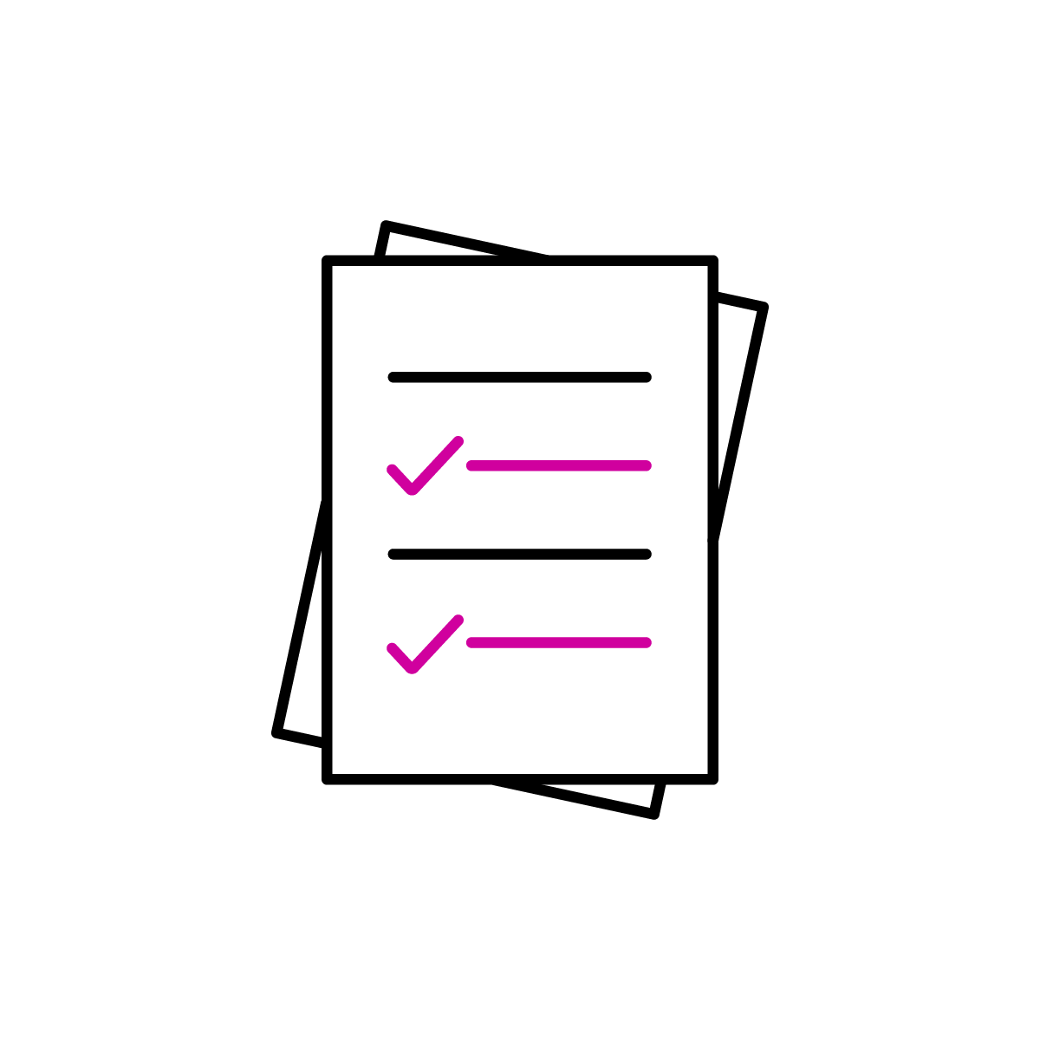  Project Name: | Scene+ Self-Serve Account Merge
Project Number | P60886
Version #: | 1.5
Last Updated: | January 10, 2024

Table of Contents
1 Version History 2
2 Document Usage and Explanation 2
3 Executive Summary and Background 3
3.1 Project Scope 3
4 Functional Requirements 3
4.1 Scene+ Self-Serve Account Merge 3
4.1.1 Current State 3
4.1.2 Future State 5
4.1.3 Self-Serve Account Merge Business Rules 7
4.2 SFMC Integration 10
4.2.1 Account Merge Confirmation Email Trigger 10
4.2.2 Membership Data Extension 10
4.3 CSM Enhancements 10
5 Assumptions 11

- Version History
Version | Date | Author | Summary
1.0 | 19 Oct 2023 | Daniel Melo | Initial Draft / Executive Summary
1.1 | 25 Oct 2023 | Geoff Charron | Internal Feedback
1.2 | 6 Nov 2023 | Daniel Melo | Expand Details
1.3 | 20 Nov 2023 | Daniel Melo | Add parameters to Account Merge endpoint
1.4 | 1 Dec 2023 | Daniel Melo | Updates to secondary MFA and reviewed Account Merge endpoint payload
1.5 | 10 Jan 2024 | Daniel Melo | Add error codes to ghost kit activation code validation error and invalid account validation error

- Document Usage and Explanation
This document outlines the technical modifications required to provide front-end enhancements to allow Scene+ members the ability to merge two accounts for those that have multiple Scene+ accounts.

- Executive Summary and Background

In an effort to enhance the overall Scene+ member experience, Scene+ has requested Bond’s support to make modifications to the front-end experience to provide members the ability to initiate an account merge independently without contacting the Scene+ Help Centre. Account Merge is the process of consolidating multiple Scene+ loyalty card accounts into a single primary account, combining points and benefits.

Project Scope

Below is the scope of work required to deliver Self-Serve Account Merge on Scene+ Web/App:

- Analysis and Technical Design
- Alignment on project objectives and stakeholder needs
- Design and documentation of a technical approach to make website enhancements to incorporate self-serve account merge features into the Scene+ experience

- Development & Delivery
- Back-End Enhancements
- Back-end modifications to provide Scene+ members the ability of moving points from one Scene+ account to another account with Scotiabank Scene+ product
- Back-end modifications to provide Scene+ members the ability of moving points from a Scene+ ghost kit account to another Scene+ black card or Scotiabank Scene+ card
- Back-end modifications to apply Account Merge business rules in Scene+ CSM to Scene+ website / app
- Back-end modifications to create an Activity History log in Scene+ CSM to show agents when a Scene+ member merged an account via website/app
- Back-end modifications to grey out the ability for Scene+ members to make changes to the DELETE account and it will appear in a read-only state to agents in CSM when the merge has been completed
- SFMC Enhancements
  - New email trigger endpoint will be delivered for notifying members when an Account Merge successfully happens (KEEP Account)
  - New email trigger endpoint will be delivered for notifying members when an Account Merge successfully happened (DELETE Account)
  - Modifications to Membership Data Extension tables to send a “Closed” status for the DELETE Account upon a successful Account Merge
- Quality Assurance and Testing
- Production Launch – Implementation and Launch Support

- Functional Requirements

Scene+ Self-Serve Account Merge

4.1.1 Current State

If a Scene+ member has multiple Scene+ accounts (i.e. Scene+ black card, Scene+ ghost kit from Empire/Home Hardware, Scotiabank Scene+ Debit/Credit Card) and want to merge two accounts into one primary account, they must contact the Scene+ Help Centre in order to complete the process and do not have the ability to do independently. Currently in CSM, agents are presented with the following screen when a member calls in requesting to merge one account (DELETE) into another (KEEP):

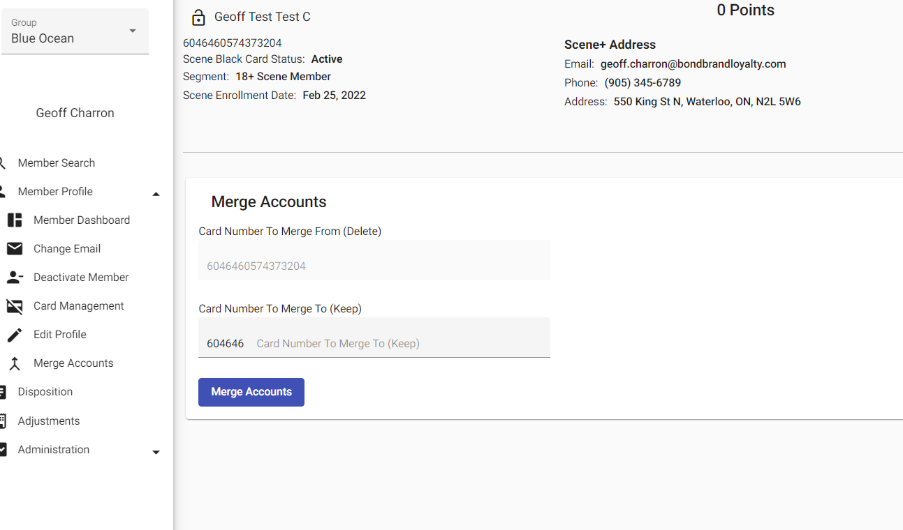

The following scenarios list out the combination of account types that may be involved in an Account Merge:

- Scenario #1: Registered Scene+ black card (DELETE) to another Scene+ black card (KEEP)
  - An existing Scene+ member owning two registered accounts each with unique first/last/email combination
- Scenario #2: Registered Scene+ black card (DELETE) to a registered Scene+ Scotiabank linked account (KEEP)
- Scenario #3: Unregistered Scene+ Ghost Kit (DELETE) to a registered Scene+ black card (KEEP)
- Scenario #4: Unregistered Scene+ Ghost Kit (DELETE) to a registered Scene+ Scotiabank linked account (KEEP)

The following 2 scenarios below are NOT ALLOWED in an Account Merge Process:

- Scenario #5: Registered Scotia linked account (DELETE) to a registered Scene+ black card account (KEEP)
- Scenario #6: Registered Scotia linked account (DELETE) to another registered Scotia linked account (KEEP)

Once the agent enters the Scene+ (KEEP) account number in CSM, they will be presented with a Verify Accounts screen to complete the process

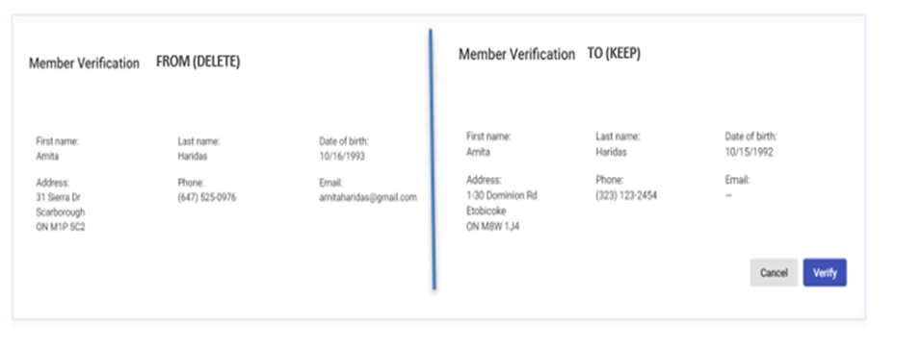

4.1.2 Future State

As part of this new feature, Scene+ will be providing members the ability to initiate an account merge independently via the Scene+ website / app.

FIGMA: https://www.figma.com/file/tMtFlfgOkssmS5hkGjQlsI/Scene%2B-Share?type=design&node-id=1900-1955&mode=design&t=hzn9tFCbxaZ7YCy9-0#605353944

Once the Scene+ member has logged in with their KEEP account, they will be able to find “Merge Account” under the Profile section:

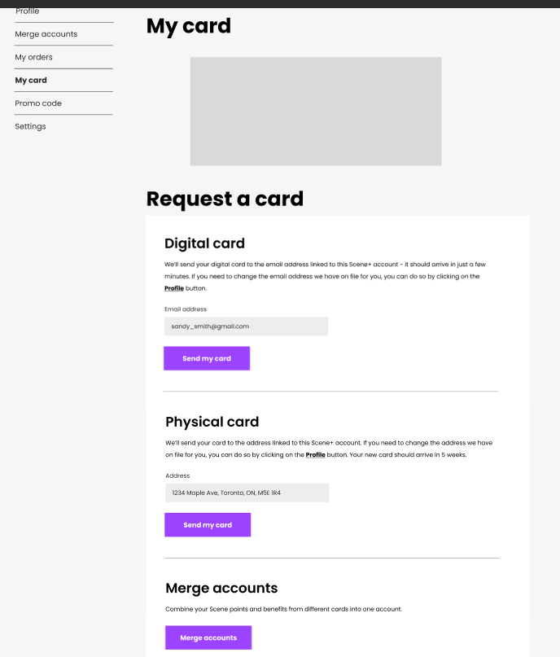

Once the member selects ‘Merge Account’, they will land on a ‘Merge Your Scene+ Card accounts page’ where they will begin to add the DELETE Scene+ account they want to merge into the KEEP / PRIMARY account. Bond assumes the creative/flow will follow a similar model that agents currently can see in Scene+ Help Centre. The following parameters need to apply:
- The Scene+ member is logged into the Primary (KEEP) Account they want to merge to before proceeding
- Scene+ member is aware of the eligibility requirements for account merge. Scene to provide final EN/FR copy, Havas to own where it goes on web/app, Bond to own back-end validations/business rules

Account Merge Eligibility Requirements

The following eligibility requirements will be implemented on the back-end by Bond to incorporate on the Scene+ web/app that will have similar logic/rules in place currently for Scene+ Help Centre:

- Ensuring both Scene+ accounts exist for the card numbers entered and are in an ACTIVE or GHOST status if merging a Ghost kit into a Scene+ black card account or Scotiabank Scene+ debit/credit account
- If Merge From (DELETE) is an unregistered Ghost Kit account, the member will be required to validate the Ghost Kit Activation Code before merging
- If Merge From (DELETE) is a Scene+ Black Card account (including registered Ghost Kit), an MFA code will be sent to the phone number in the Merge From (DELETE) account and the member will be required to validate the MFA code
- The logged in account will be limited to 2 (configurable) account merges through the website per year (12 months rolling window). If the limit is reached, the merge fields will not be available and an error message will be presented advising “Account Merge limit reached”.

Merge FROM (DELETE) Validation Error Messages

- If a Merge From (DELETE) field has a card number that is linked to a Scotiabank product, present an error message advising “Account related to card # X is Scotiabank linked and not eligible for merge”
- If a Merge From (DELETE) field has a card number for which the associated account has “In Progress” or “Pending” redemption orders, present an error message saying “Account belonging to card X cannot be merged as pending/in-progress orders are detected”
- If a Merge From (DELETE) field has a card number showing a Suspended status, present an error message advising “Card X belongs to a suspended account – not eligible for merge”
- If a Merge From (DELETE) field has a card number showing a Closed status, present an error message advising ‘Card X belongs to a closed account – not eligible for merge”

Merge TO (KEEP/PRIMARY) Validation Error Messages
- If Merge TO (KEEP) field has a card # for which the associated account is Suspended, present an error message saying, “Card 1234567890 belongs to a suspended account – not eligible for merge”
- If Merge TO (KEEP) field has a card # for which the associated account is Closed, present an error message saying, “Card 1234567890 belongs to a Closed account – not eligible for merge”.
- If Merge TO (KEEP) field has a card # for which the associated account is unregistered (Ghost Card Kit), present an error message saying “Unable to merge into an unregistered account (Keep).

Summary of Account Merge Validations

Account Status | Merge From (DELETE) | Merge To (KEEP) | Error Message
Unregistered (Ghost) | Allow | Prevent | Unable to merge into an unregistered account (Keep).
Enrolled (Black Card) | Allow | Allow | N/A
Enrolled (Scotiabank linked) | Prevent | Allow | Account related to card # 1234567890 is Scotiabank linked and not eligible for merge
Suspended | Prevent | Prevent | Card 1234567890 belongs to a suspended account – not eligible for merge
Closed | Prevent | Prevent | Card 0987654321 belongs to a closed account – not eligible for merge

Once the member has entered 2 Scene+ card numbers and the initial validation is successful, the member will see an Account Merge verification pop-up screen in a READ-ONLY state to confirm one final time the account to KEEP and the one to merge/DELETE.

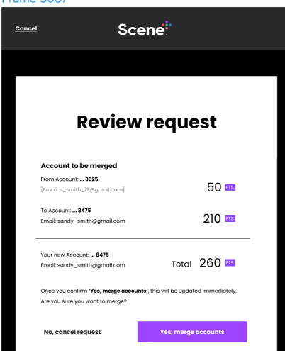

- If a Scene+ member changes their mind and selects Cancel, the pop-up window closes and member remains on the Merge your Scene+ accounts screen with the data fields populated for the Scene+ accounts.
- A member may cancel this window in order to and make changes and/or re-enter a different account number

Once the Scene+ member selects Verify/Confirm to move forward with the account merge, Bond assumes a new pop-up window will be displayed to the user once an account merge has successfully went through similar to what members see for a Send My Card request. A confirmation email will be sent to the PRIMARY member’s account confirming the account merge went successfully through.

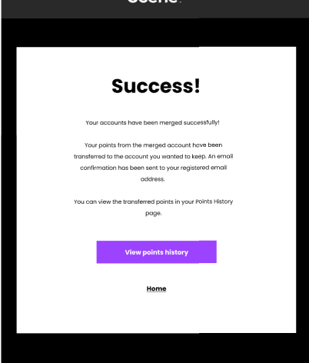

4.1.3 Self-Serve Account Merge Business Rules

As part of the Self-Serve Account Merge implementation, Bond will make back-end changes that mimic the business rules/validations currently in place for the Scene+ Help Centre in order for a member to successfully merge one account into another. These rules/validations are described in details under section 4.1.2 Future State, and its subsection “Account Merge Eligibility Requirements”. Given the accounts are validated, the following business rules will be applied:

Executing a Merge

- The DELETE account will receive an Account Activity record “Merged Account” with a message stating the account has been merged into another account (PRIMARY or KEEP)
  - A new record will be created in Scene+ CSM indicating the account merge occurred via Web/App and the record including Account, Scene+ card number closed (DELETE) and Scene+ card number merged to (KEEP)
  - The DELETE card status will be marked as CLOSED once successfully merged
- The KEEP account will receive an Account Activity record “Merged Account” with a message stating the account has been merged from another account (DELETE)
  - A new record will be created in Scene+ CSM indicating the account merge occurred via Web/App and the record including Account, Scene+ card number closed (DELETE) and Scene+ card number merged to (KEEP)
- DELETE/CLOSED accounts will still be accessible for Call Centre agents and will be presented greyed out and in a read-only state to review account history information (i.e. Activity, Points, Order, Disposition and Adjustment)
  - Existing profile data rules for closed accounts will still apply where a member could use an email/phone number for a future profile or active profile
- Account Merge cannot be reversed once it has been successfully applied

Data Merge

- Points from the DELETE account will move to the KEEP/PRIMARY account during the merge with two point records in Scene+ CSM showing a positive adjustment to the KEEP/PRIMARY account and a negative adjustment to the DELETE account
  - Bond will create a new Points History transaction record to be featured on Web/App to confirm the member successfully merged points into their PRIMARY account, along with a record in CSM highlighting the merge occurred via web/app
- NO member profile details will come from the DELETE account profile, only points merged
- Scene+ card number and status will be for the KEEP/PRIMARY account

Account History Rules

- Outside of combining points into the KEEP/PRIMARY account, all history records (Activity, Disposition, Order and Point) will remain with each account and can be viewed in a read-only state for the deleted account in Scene+ Help Centre.
  - Members will be unable to view any historical transactions on Web/App once a self-serve account merge has been completed successfully
- The Activity History record in the KEEP/PRIMARY account will capture the merge Account number that was CLOSED/DELETED
- The Activity History record in DELETE/CLOSED account will capture the Account number the points were merged into (KEEP/PRIMARY)
- Upon a successful account merge completed via web/app, the following fields will be captured to show in CSM
  - Date & Time of Merge, Web/App identifier, label & value of merge FROM (DELETE) card # & account #
  - Label & value of merge TO (KEEP) card # and account #
  - Label and points balance of FROM (DELETE) at time of merge
  - Label and new combined points balance for Merge KEEP/PRIMARY account

API details

Ghost Kit Verification

The existing API for verifying a Ghost Kit activation code will be leveraged for the verification when a Ghost Kit account is entered as the Merge From (DELETE) account. No changes will be made to the API.
Request:
{
"cardNumber": "6046467899783686",
"activationCode": "16481"
}

The response will be an empty response with error code in the 200 HTTP family.

Error Codes

The error messages below are returned by the API and should not be used for notifying members in the front-end.
Code | Error Message | Trigger Condition
AccountNumberRequired | Card Number required / Card Number cannot be empty | Card Number is not specified or is empty
AccountNumberLength | Card Number should be 16 characters long | Card Number specified has wrong format
AccountActivationCodeRequired | Account ActivationCode required / Account ActivationCode cannot be empty | Activation code is not specified or is empty
ActivationCodeLength | Account ActivationCode should be 5 characters long | Activation code specified has wrong format
GhostKit.Account.VerificationFailed | The verification failed for the CardNumber and ActivationCode | The Activation Code for the card number is incorrect.

Account Merge
A new API with the following payload will be leveraged for the Self-Serve Account Merge. One additional parameter will be received for validating Ghost Kit DELETE accounts. Additionally, a new structure that will be populated by B2C during the MFA process will be used by the API to validate a registered DELETE account has been successfully verified through MFA. This validation requires no additional parameters to the Request body or headers.

Request
{
"deleteAccountNumber": "6046467899783686",
"keepAccountNumber": "6046468708095221",
"deleteGKActivationCode": "12345"
}

Response
{
"statusCode": …,
"statusReason": …,
"requestMethod": "…",
"requestUri": "…",
"product": "…",
"apiName": "…",
"responseTimestamp": "…",
"acknowledgmentToken": "…",
"data": {
"deleteAccountNumber": "6046467899783686",
"keepAccountNumber": "6046468708095221",
"beforeMergeKeepAccountBalance": "2000",
"afterMergeKeepAccountBalance": "3000",
"beforeMergeDeleteAccountBalance": "1000",
"afterMergeDeleteAccountBalance": "0"
}
}

Error Codes

The error messages below are returned by the API and should not be used for notifying members in the front-end.
Code | Error Message | Trigger Condition
MergeLimitReached | MergeLimitReached | The configurable merge limit has been reached for the Primary (KEEP) account
DeleteAccountNotAuthenticated | DeleteAccountNotAuthenticated | The Merge From (DELETE) account has not been successfully verified through MFA while logged into the Merge To (KEEP) account, or the Ghost Kit activation code is incorrect
DeleteAccountScotiaLinked | DeleteAccountScotiaLinked | The Merge From (DELETE) account is linked to a Scotiabank product
DeleteAccountSuspended | DeleteAccountSuspended | The Merge From (DELETE) account is Suspended
DeleteAccountClosed | DeleteAccountClosed | The Merge From (DELETE) account is Closed
DeleteAccountHasPendingOrders | DeleteAccountHasPendingOrders | The Merge From (DELETE) account has orders for which the current status is either Pending or In Progress
KeepAccountSuspended | KeepAccountSuspended | The Primary (KEEP) account Is Suspended
KeepAccountClosed | KeepAccountClosed | The Primary (KEEP) account is Closed
KeepAccountUnregistered | KeepAccountUnregistered | The Primary (KEEP) account is an Unregistered Ghost Kit
AccountsAlreadyFromSameProfile | AccountsAlreadyFromSameProfile | The Primary (KEEP) account and the Merge From (DELETE) account are already linked to the same member profile. This is only possible when one of the accounts refers to a Scotiabank product and is additional to the Scotiabank Linked validation. The same member profile can’t contain more than one Scene+ Black Card account
GhostKitVerificationFailed | GhostKitVerificationFailed | The Ghost Kit activation code is invalid or doesn’t match the Delete Ghost Kit account activation code.
AccountNumberInvalid | AccountNumberInvalid | Keep or Delete account number entered is invalid, is less than 16 digits long, doesn’t exist or has been replaced.

B2C “MFA” Flow

According to the Figma design, the following web screen will require a selection between a Registered or Unregistered account for merging, and a confirmation.

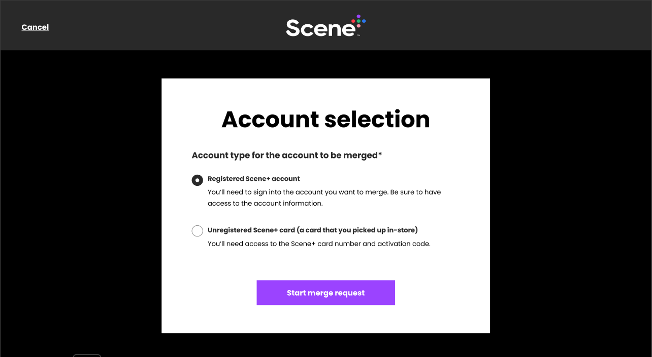

Once Registered Scene+ account is selected and the button “Start merge request” is clicked, a new B2C policy will be triggered by the Web/Mobile application. The B2C flow will be composed of the next 3 screens in the Figma design, responsible for retrieving the DELETE Card Number, triggering and finishing a phone validation, which will be the existing validation currently applied as MFA during the Scene+ login process.
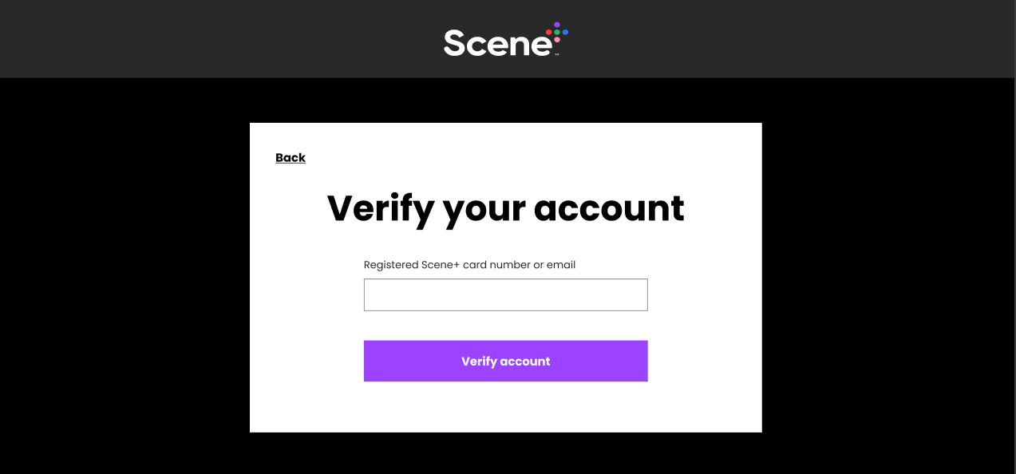

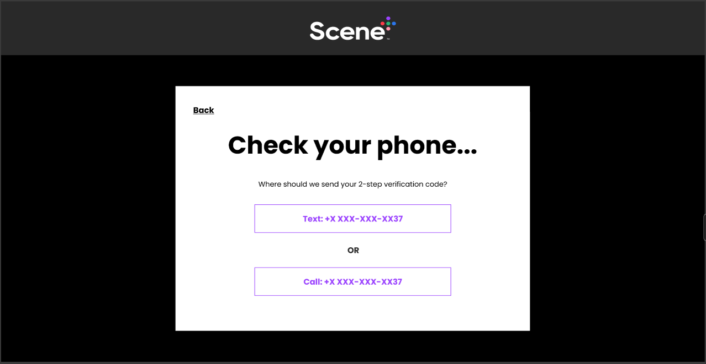
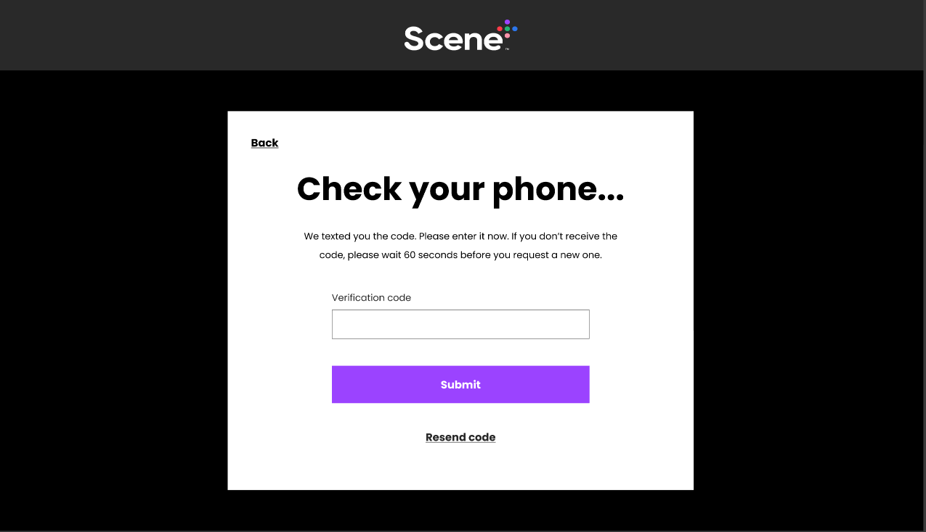

Once the phone validation is successful, it’ll redirect back to the Web/Mobile application. The application will be called with a token parameter. This token will contain a new Claim called “deleteAccount”. This claim will contain the DELETE account Card Number and must be used by the Web/Mobile application to display the account details in the subsequent confirmation screens, which will reside on the Web/Mobile application, and to send in the Request body of the Merge API as “deleteAccountNumber”.

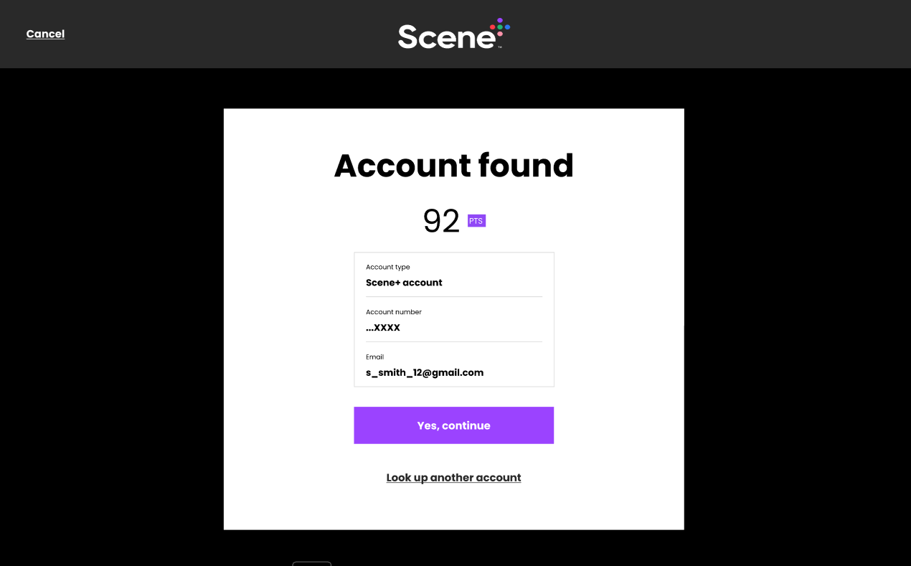
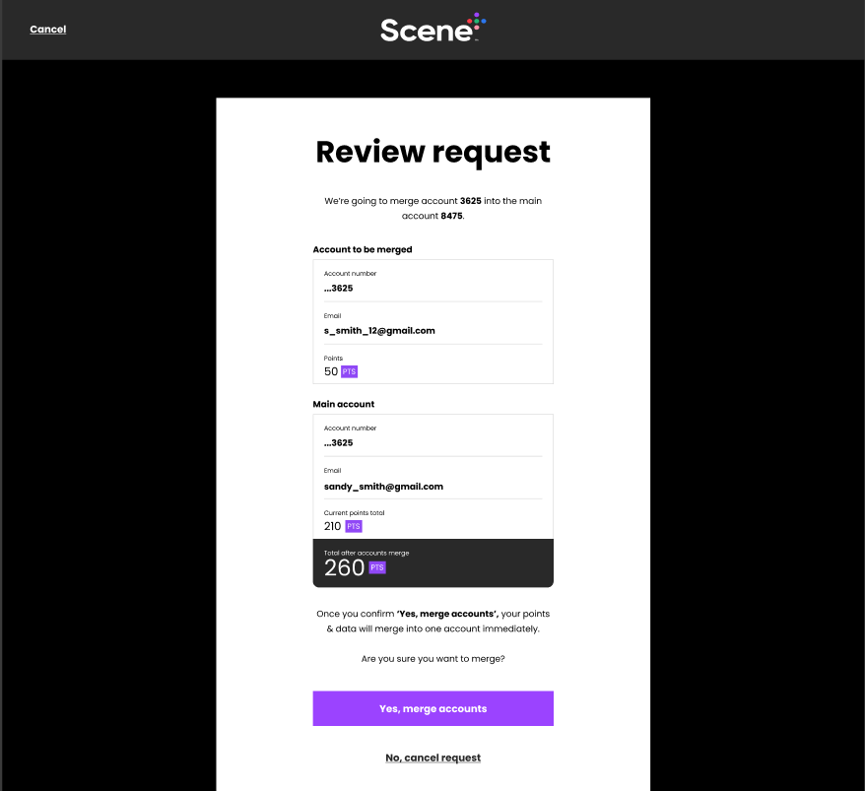

Once the button “Yes, merge accounts” is clicked, the Web/Mobile application will call the Merge API detailed in section 4.1.4 API Details

All screenshots in this section are based on the Figma designs referenced in section 4.1.2 Future State. Please refer to the Figma link for the most up-to-date designs.

SFMC Integration

In order to deliver effective one-to-one communications, enhancements will be made to the Salesforce Marketing Cloud integration, specific to member communication.

4.2.1 Account Merge Confirmation Email Trigger

As part of the SFMC enhancements for Account Merge, a new email trigger will be delivered for notifying members when account merges happen. The new email template will be set up on SFMC by Scene+.
Real-time after every account merge, Bond will send an email request with the new notification template to the KEEP account email address, and another request to the DELETE account email address.

Scene+ to provide Bond with details of what the new template will require. The details of the new template will be as follows:
Template Code:
Payload:

4.2.2 Membership Data Extension

As part of the Account Merge process, an update for the DELETE account will be sent to SFMC through the Membership Data Extension after the Account Merge is done, to update the account status to Closed. This update will not be any different from other updates sent to the Data Extension and no changes to the data extension will be made. The same triggers that automatically send updates for accounts that are closed by other means will be responsible for sending this update, and no changes will be made to them.

CSM Enhancements

- Activity record in CSM in KEEP Account showing account merge with FROM card # to TO card # details similar to CSM description now – indicating merge happened from Web/App
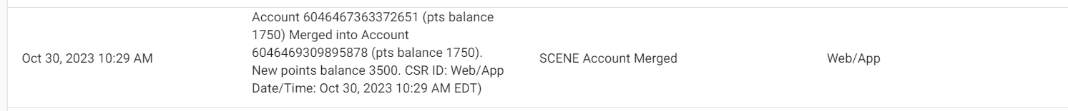
- Activity record in CSM for DELETE account showing it happened from Web/App
- Validating DELETE accounts are greyed out in read-only state when successfully merged from Web/App
- Points History validation showing updated point balances in CSM accounts

- Assumptions
- Functional Specifications are based on Scene+’s Business Requirements Documentation provided to Bond
- Website and Mobile App front-end implementation will be executed by Havas and will follow the designs available in Figma https://www.figma.com/file/tMtFlfgOkssmS5hkGjQlsI/Scene%2B-Share?type=design&node-id=1900-1955&mode=design#605353944
- The same email trigger and template will be used for the emails sent to the Primary (KEEP) and to the Merge From (DELETE) accounts. Any differentiation between the two will be based only on the payload sent to SFMC with the email request
- Scene+/Havas will be responsible for all front-end E2E testing of new Self-Serve Account Merge on website/app. Bond will provide postman results as part of back-end testing
- Scene+/Havas to make content related changes within Agility
- Havas will be responsible for adding and creating new page modules in Agility
- Bond will be responsible for the implementation of the new B2C policy, including the 3 pages of the “MFA” flow for merging Registered accounts only
  - Havas will be responsible for the implementation of the other screens in the Figma designs in the Web and Mobile applications
- Havas will be responsible for triggering the B2C policy from the Web/Mobile application once the event is triggered by the user, and will be responsible for receiving the token from the “MFA” flow and reading the claims to fetch the DELETE Card Number

- Appendix B - BRD

